Patrick Morley

Professor Holden-Gouveia

Linux Administration

Continue Setup Lab

**CentOS:**

Repositories:

Yum repolist shows what repos are enabled. Yum repolist all shows all enabled and disabled repos. Dnf config-manager –add-repo <http://rpms.famillecollet.com/enterprise/remi-release-7.rpm>

INSTALLS:

I connected to wifi by entering these commands: chkconfig NetworkManager on, service NetworkManager start, and nmtui. This launched the network manager text user interface which I used to connect to my wifi. After this I was able to run yum update.

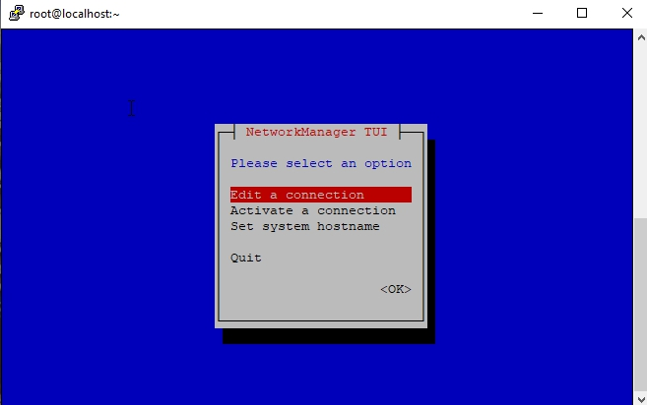

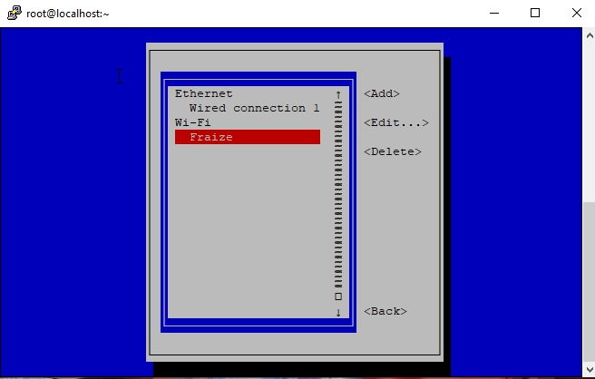

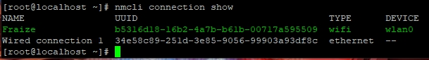

Yum install tmux

While trying to install emacs I found out I had no more space left on my partition. So, I had to figure out how to expand my partitions because I was only using about 2GB of my 32GB SD card. I used yum install parted to install a program I could use to configure my partitions. I used command parted to enter the program and print to see how my partitions were set up. Next I entered resizepart, when asked Partition number? I entered 3, when asked End? [GB]? I entered 250000 (for 25GB). I then did a reboot. Fdisk /dev/mmcblk0 then command p showed the partition was larger, but the root file system still had its old size. Next, I used resize2fs /dev/mmcblk0p3 to extend the root file system. E2fsck -f /dev/mmcblk0p3 checked for errors, and df -h showed that I now had 21GB of space left.

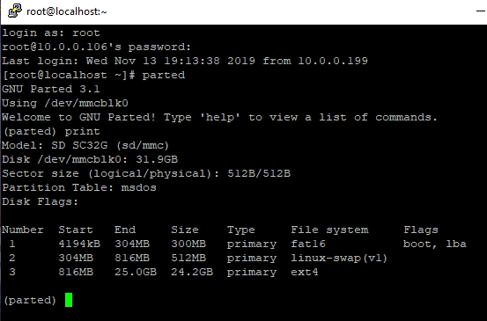

Yum install emacs

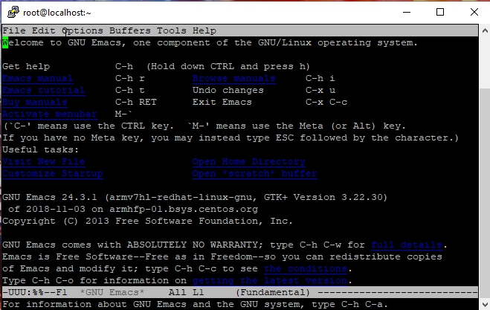

I cannot install Fail2Ban without installing the EPEL repository first and there is no EPEL for my version of CentOS. I also cannot install cowsay or fortune without the EPEL repository either.

I did manage to install lolcat with these steps. Yum install ruby, Yum install wget, Wget <https://github.com/busyloop/lolcat/archive/master.zip>, Yum install unzip, Unzip master.zip, cd lolcat-master/bin, gem install lolcat.

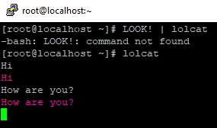

Update VI to vim:

Sudo rpm -Uvh <http://mirror.ghettoforge.org/distributions/gf/gf-release-latest.gf.el7.noarch.rpm>

Sudo rpm –import <http://mirror.ghettoforge.org/distributions/gf/RPM-GPG-KEY-gf.el7>

Sudo yum -y remove vim-common vim-enhanced vim-filesystem

Sudo rpm -e –nodeps vim-minimal

Sudo yum -y –enablerepo=gf-plus install vim-enhanced

**Ubuntu:**

Repositories:

List repositories: grep ^[^#] /etc/apt/sources.list or sudo grep -Erh ^deb /etc/apt/sources.list*

^[^#] suppresses comments. /etc/apt/sources.list.d is the directory where the information is maintained.

List installed packages: sudo apt-cache policy

Before I changed anything, I used: sudo cp /etc/apt/sources.list /etc/apt/sources.list.backup to create a backup file in case I messed up and needed to recover the file.

In order to add repositories, I used: sudo vi /etc/apt/sources.list to enter the editor. Then I removed the # from 2 of the repositories to uncomment them and put them into effect.

I also used: sudo add-apt-repository “deb <http://us.archive.ubuntu.com/ubuntu/> saucy universe multiverse” to add another repository. I added a # in the editor to comment this out.

I used: lsb_release -sc to find out what my release is. It is bionic.

I updated my system and new repositories with sudo apt-get update.

I added the PPA repository with: sudo add-apt-repository ppa:Thomas-schiex/blender and installed blender with sudo apt-get install blender. Then I removed it with: add-apt-repository –remove ppa:Thomas-schiex/blender. I then used sudo apt-get install ppa-purge and used ppa-purge ppa:Thomas-schiex/blender to fully remove it from the system. You could also manually remove it from the system with: sudo rm /etc/apt/sources.list.d/Thomas-schiex-ubuntu-blender-bionic.list

I used: sudo apt-get upgrade to upgrade my system.

The first step I took in installing a package was to search for one. I used sudo apt-cache search rhythmbox. You can upgrade the package with sudo apt-get upgrade rhythmbox. Or you can remove the package with: sudo apt-get remove rhythmbox. Or purge it with sudo apt-get remove –purge rhythmbox.

In order to clean out your caches and get back some hard drive space you can use 2 commands. Sudo apt-get clean. Or to clean out your cache and save the newest versions of the packages you can use: sudo apt-get autoclean.

Installs:

Installing Tmux was pretty easy. I just use: sudo apt-get install tmux and it was ready to use. I always use sudo apt-get update before and after I install something new and I make sure I use sudo apt-get upgrade every so often too. The command tmux starts a session. Ctrl-b d gets you out of a session. And tmux new -s test creates a new session called “test”; you can replace “test” with whatever name you want to call it.

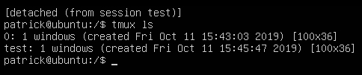

In order to install emacs, you first have to install the ppa. Sudo add-apt-repository ppa:kelleyk/emacs. Then use sudo apt update and sudo apt install emacs26. Type the command emacs to enter the program. There is a tutorial to check out in emacs and you can navigate to the home directory. You can use the up and down arrows to navigate or use ctrl-v to move down or ctrl-b to move up.

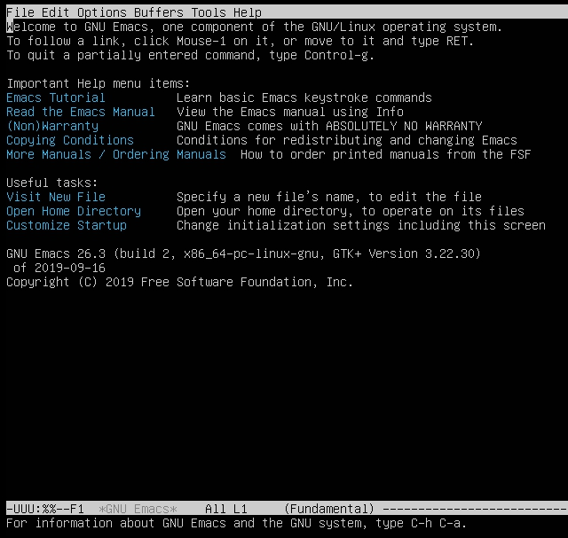

I used sudo apt-get update && apt-get upgrade -y to ensure my system was up to date. Then I used sudo apt-get install fail2ban. Fail2ban is program that automatically seeks out attackers on your system and blocks their IP address. Once you install fail2ban it automatically starts working. If you want to make any changes to this program it’s best to create a new file: sudo cp /etc/fail2ban/fail2ban.conf /etc/fail2ban/fail2ban.local.

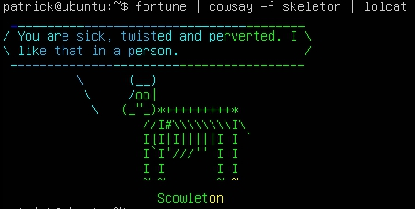

I used sudo apt-get install vim to upgrade vi to vim.

How to install and enable canonical-livepatch:

I registered at auth.livepatch.canonical.com to get a token (code).

I used sudo apt install snapd to install snap which is the program used to install canonical-livepatch.

Sudo snap install canonical-livepatch

Sudo canonical-livepatch enable xxxxc4xxxx67xxxxbxxxxfbxx4e (not my real token)

Sudo canonical-livepatch status

SSH:

